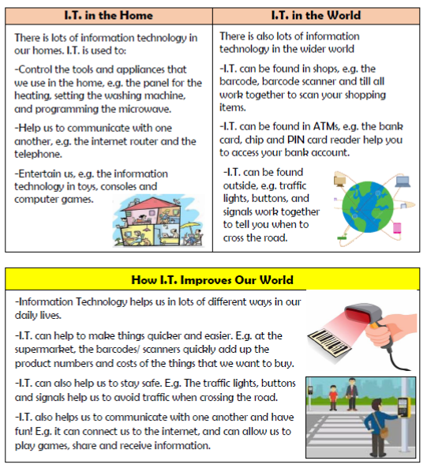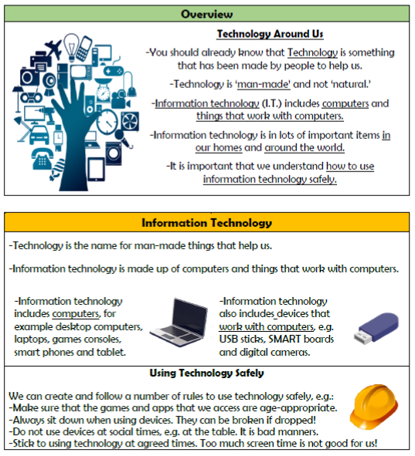

**Vocabulary**

**Information Technology, Computer, Device, Barcode, Scanner, Communication, Entertainment, Appliances, Signal, E-Safety**

**Computing systems and networks**

**Knowledge Organiser Year 2**