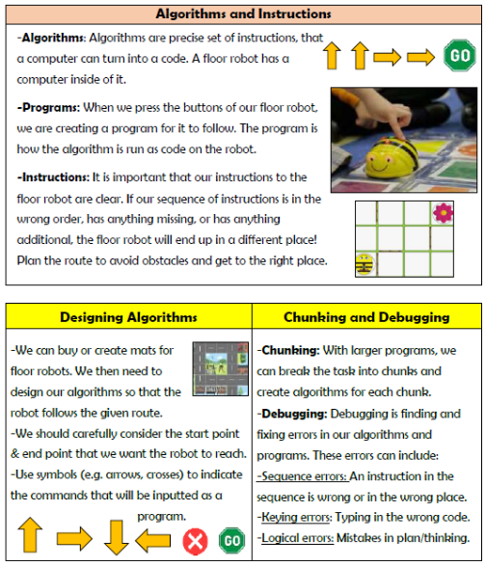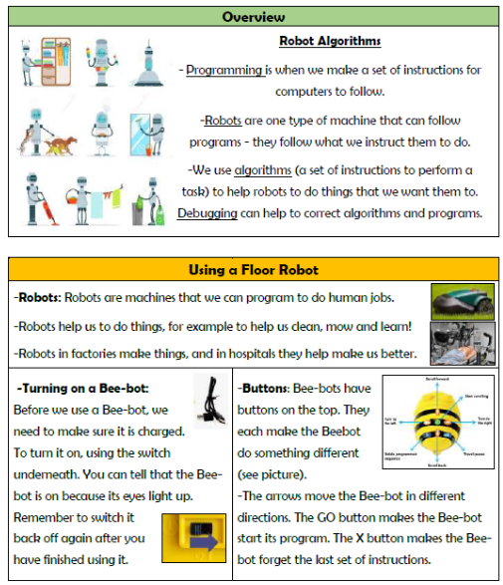

**Vocabulary**

**Program, Robot, Algorithm, Direction, Route, Obstacle, Design, Error, Chunking, Debugging**

**Computing- Programming**

**Knowledge Organiser Year 2**