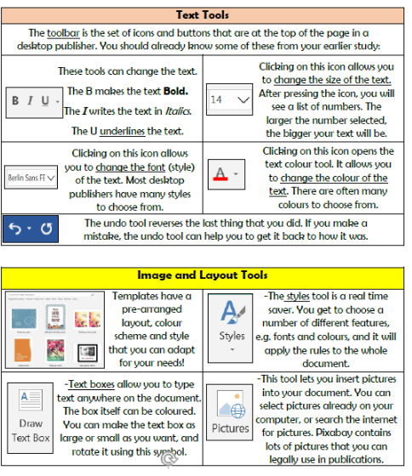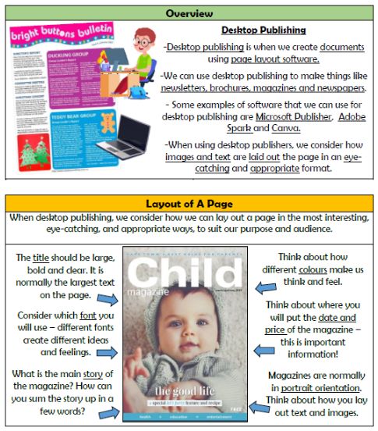

**Vocabulary**

**Publishing, Text, Images, Font, Templates, Orientation, Placeholders, Software, Purpose, Audience**

**Creating Media- Desktop Publishing**

**Knowledge Organiser Year 3**