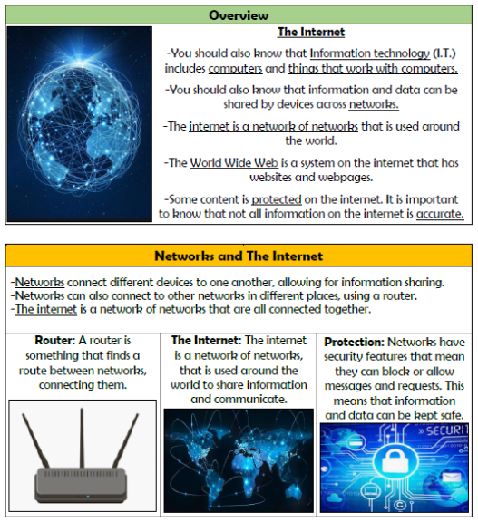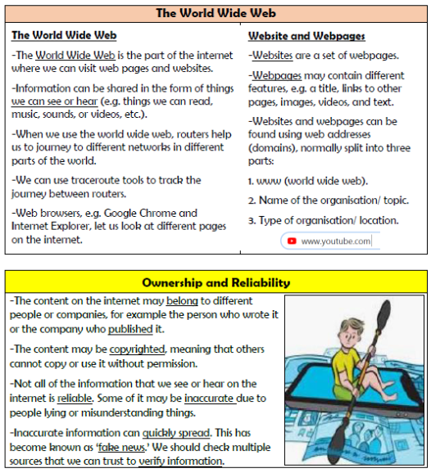

**Vocabulary**

**Network, Internet, World Wide Web, Router, Security, Website, Webpage, Browser, Domain, Reliable**

**Computing Systems and Networks**

**Knowledge Organiser Year 4**