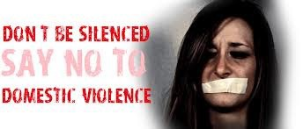
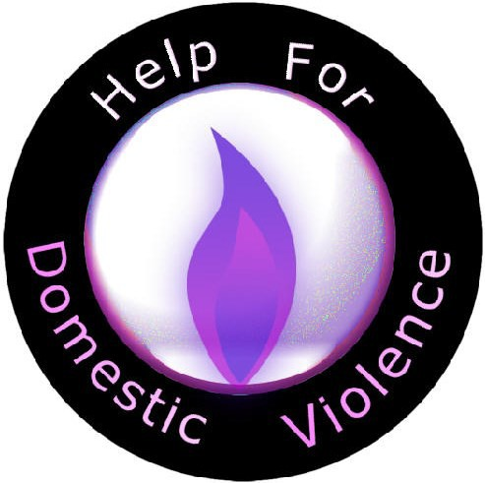
The role of the IDVA

We work with victims of domestic abuse including ‘Honour’ - based violence and forced marriage.
Support with civil and criminal justice matters.
Support from the point of crisis.

Assess the level of risk and develop safety plans.
Advocate on behalf of victims. Provide an outreach service. Multi-agency working.
Independent Domestic Violence Advisor IDVA
Tel: 0161 770 1572
Useful Contact Numbers Emergency housing out of hours: 0800 328 7788

Freephone: 24hr National Domestic Abuse helpline 0808 2000 247
Manchester Domestic Violence helpline - 0161 636 7525
FCHO: 0161 393 7117

Police Non Emergency 101 Emergency 999

Useful websites www.womensaid.org.uk Karma Nirvana
Tel: 08005999247

www.karmanirvana.org.uk Men’s AdviceLine
Tel: 0808 8010327

info@mensadviceline.org.uk

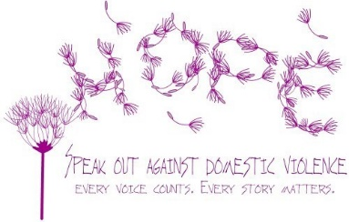
Domestic Violence Definition:
contact the
IDVA service.

Any incident or pattern of incidents of controlling, coercive or threatening behaviour, violence or abuse between those aged 16 or over who are or have been intimate partners or family members regardless of gender or sexuality. This can encompass but is not limited to the following types of abuse:
- psychological

- physical

- sexual

- financial

- emotional

*This definition includes so called ‘honour’ based violence, female genital mutilation (FGM) and forced marriage, and is clear that victims are not confined to one gender or ethnic group.
Home Office, 2012

Overcoming Domestic Violence Group

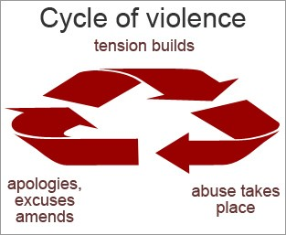
The group programme is aimed at working with people who have experi- enced abuse within intimate relation- ships and whom are no longer within the relationship.
The group explores abusive behaviours, abusive/ healthy relationships, impacts on children and much more.

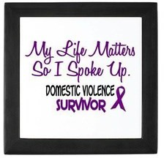
For further information

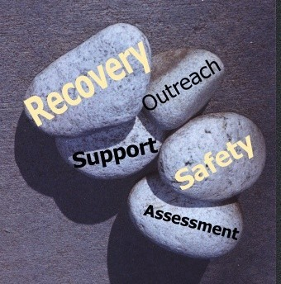

IDVA Contact Details Phone: 0161 770 1572
Email

Idaa.service@oldham.gov.uk

Secure

IDVA.service@oldham.gcsx.gov.uk

LGBT IDVA

Phone: 0161 636 7525

idvalgbt@independentchoices.org.uk

