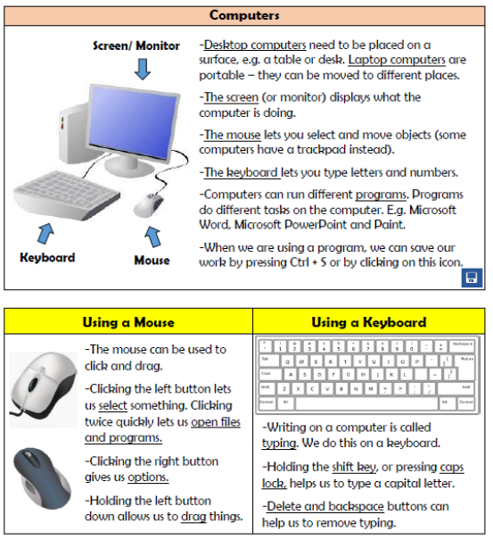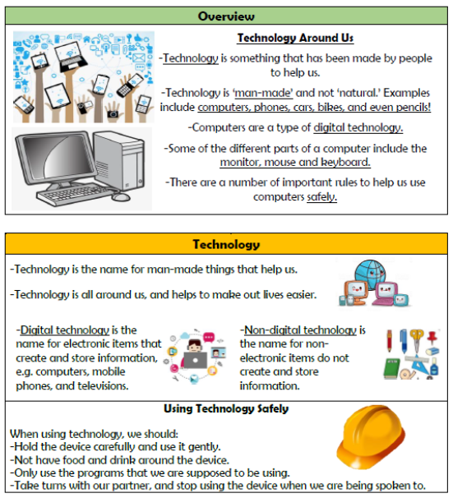

**Computing Systems and Networks**

**Knowledge Organiser Year 1**

**Vocabulary**

**Technology, Man-made, Digital, Screen, Mouse, Keyboard, Program, Click, Drag, Cursor, E-Safety**