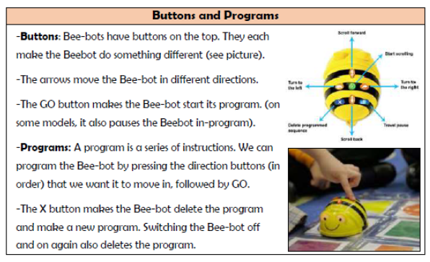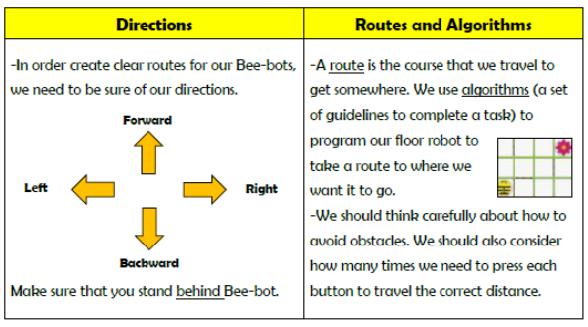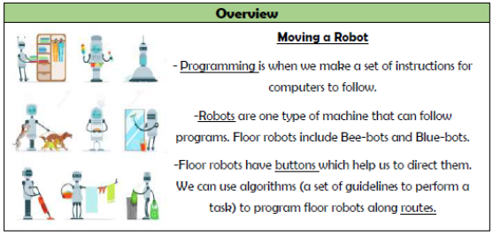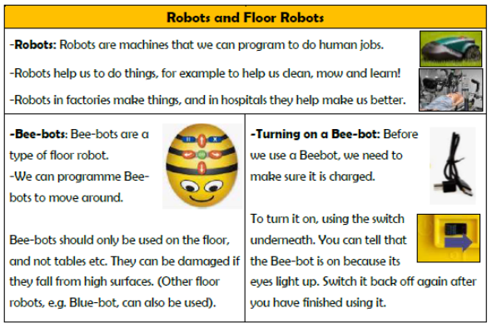

**Vocabulary**

**Programmed, Robot, Algorithm, Button, Direction, Forward, Backward, Left, Right, Route**

**Computing – Programming**

**Knowledge Organiser Year 1**