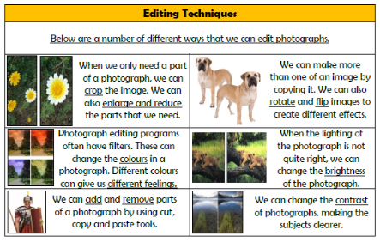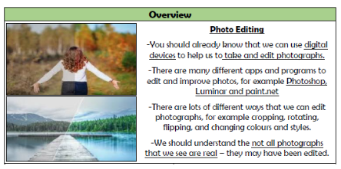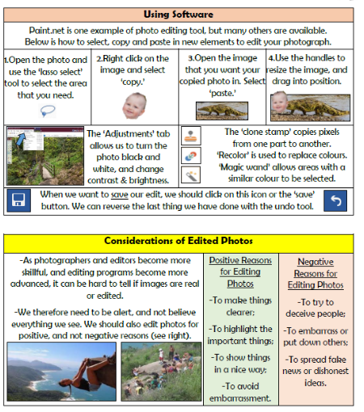

**Vocabulary**

**Photography, Editing, Software, Crop, Rotate, Flip, Copy, Contrast, Brightness, Enlarge, Reduce**

**Creating Media- Photo Editing**

**Knowledge Organiser Year 4**