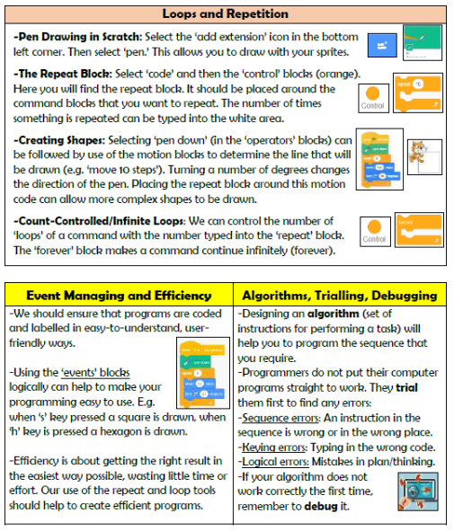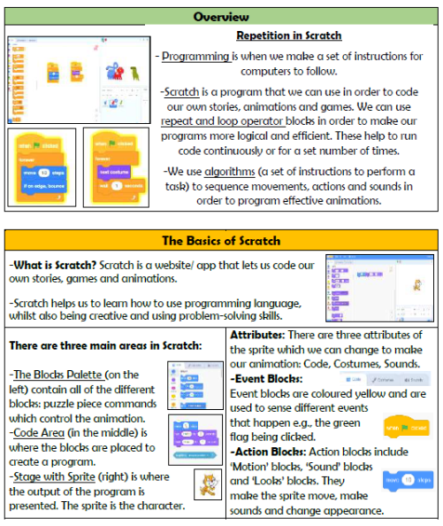

**Vocabulary**

**Programming, Scratch, Blocks, Commands, Code, Events, Motion, Sequence, Trialling, Debugging**

**Computing- Programming**

**Knowledge Organiser Year 4**