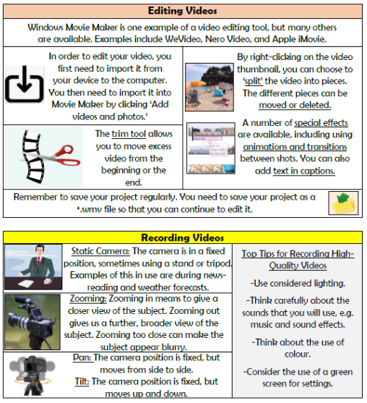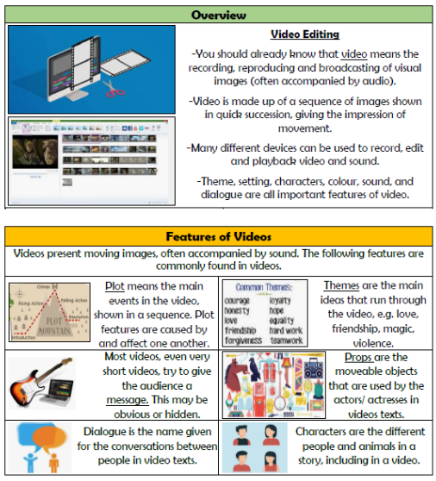

**Vocabulary**

**Video, Audio, Themes, Message, Dialogue, Plot, Props, Zoom, Angle, Pan, Tilt**

**Creating Media- Video Editing**

**Knowledge Organiser Year 5**