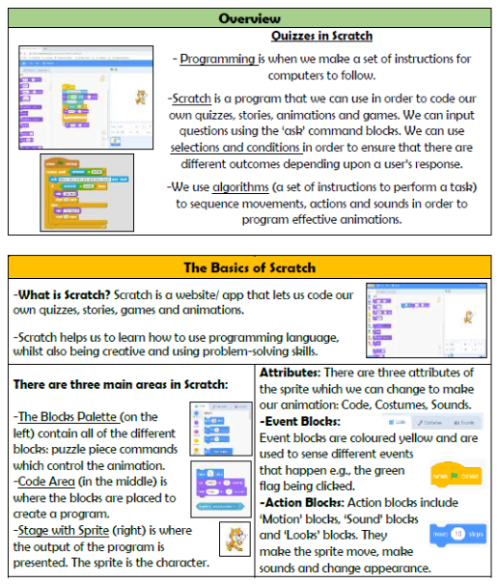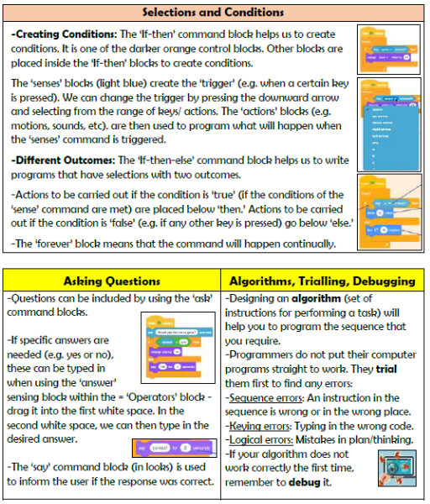

**Programming- Selection in quizzes**

**Vocabulary**

**Programming, Scratch, Logical, Commands, Algorithm, Condition, Selection, Sequence, Trialling, Debugging**

**Knowledge Organiser Year 5**