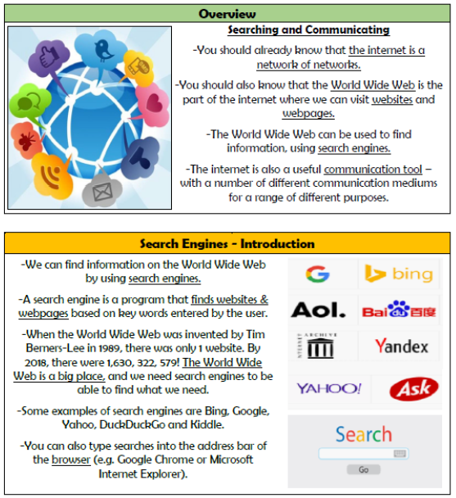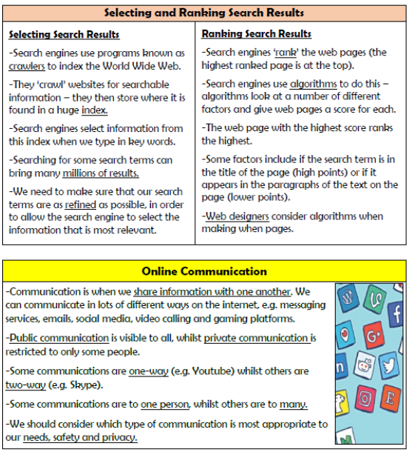

**Vocabulary**

**Internet, World Wide Web, Search Engine, Browser, Keyword, Google, Tim Berners-Lee, Ranking, Crawlers, Algorithm**

**Computing systems and networks**

**Knowledge Organiser Year 6**