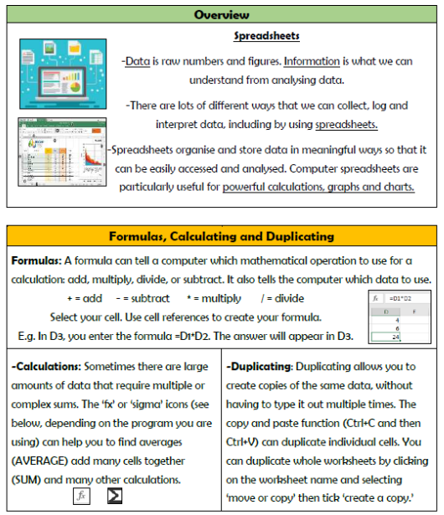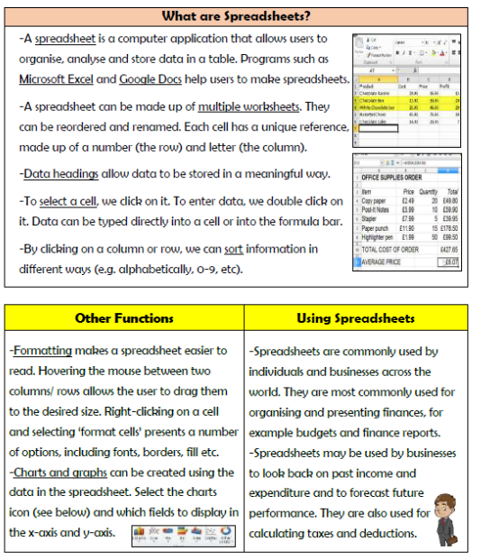

**Vocabulary**

**Information, Data, Spreadsheet, Format, Formula, Accounting, Filter, Software, Tax, Business**

**Data and Information**

**Knowledge Organiser Year 6**