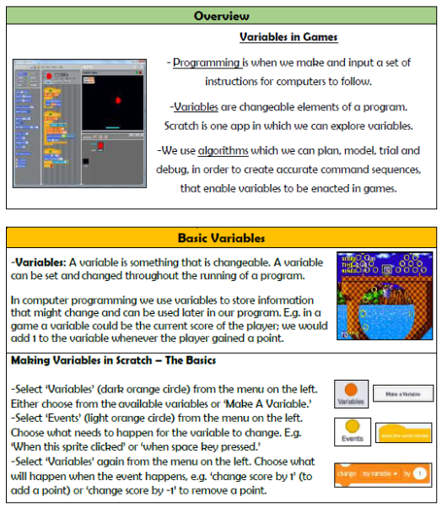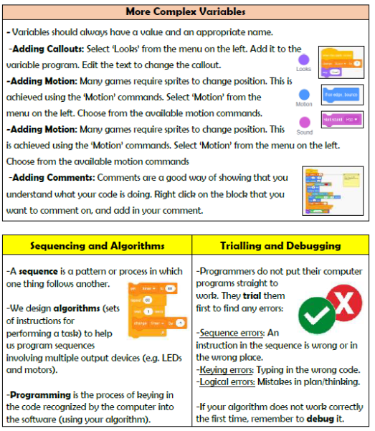

**Vocabulary**

**Programming, Variables, Scratch, Events, Code, LED, Algorithm, Motor, Debugging, Modify**

**Computing-Programming**

**Knowledge Organiser Year 6**